**Batch: B2 Roll No.: 1611103**

**Experiment / assignment / tutorial No.06**

**Grade: AA / AB / BB / BC / CC / CD /DD**

**Signature of the Staff In-charge with date**

|  |
| --- |
| **TITLE :Vector and array of objects and Enumeration/Iterator** |

**AIM :** Create a class **ShoppingList** which stores Name of the items ,item id ,cost, and total no.of a items. Use class Vector to maintain an array of items in the descending order of the cost.

1. Accepts a shopping list from the command line and stores them in a vector.
2. To delete an specific item (given by user) in the vector
3. Add item at the end of the vector
4. Add item at specific location

Print the contents of vector.

Provide the following functions

1) create() : this function will accept the n items records in any order and will arrange them in the sorted order. This data will be accepted from the command line and stores them in a vector.

2) insert : to insert the given item at appropriate index in the vector depending upon the grand total.

3) deleteByName( ) : to accept the name of the item and delete the record having given name

4) deleteById( ): to accept the id of the item and delete the record having given roll no.

**______________________________________________________________________**

**Expected OUTCOME of Experiment:**

**CO2:**Solve problems using Java basic constructs (like if else statement, control structures, and data types, array, string, vectors, packages, collection class).

**_____________________________________________________________________**

**Books/ Journals/ Websites referred:**

1. Ralph Bravaco , Shai Simoson , “Java Programing From the Group Up” Tata McGraw-Hill.

2.Grady Booch, Object Oriented Analysis and Design .

**__________________________________________________________**

**Pre Lab/ Prior Concepts:**

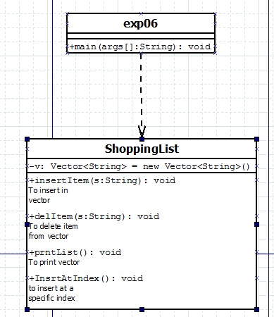**Class Diagram:**

**Algorithm:**

* + - 1. Start
      2. Take the operation to be performed by the user as an int input.
      3. Perform the following operation using switch case
      4. Stop.

**Implementation details:**

**import java.util.*;**

**public class exp06**

**{**

**public static void main(String args[])**

**{**

**Scanner in = new Scanner(System.in);**

**int x ;**

**ShoppingList list1 = new ShoppingList();**

**for(int i = 0;i<args.length;i++)**

**{**

**list1.insertItem(args[i]);**

**}**

**do**

**{**

**System.out.println("**************MAIN MENU*****************");**

**System.out.println("Select option:");**

**System.out.println("1.Insert Element\n2.Delete Element\n3.Print\n4.Insert at specific index\n5.Exit");**

**x = in.nextInt();**

**switch(x)**

**{**

**case 1: System.out.print("Enter the element to be Inserted : ");**

**list1.insertItem( in.next() );**

**break;**

**case 2: System.out.println("Enter the element to be deleted :");**

**list1.delItem( in.next() );**

**break;**

**case 3: list1.prntList();**

**break;**

**case 4 : list1.InsrtAtIndex();**

**default:break;**

**}**

**}while( x != 5 );**

**in.close();**

**}**

**}**

**class ShoppingList**

**{**

**private static Vector<String> v = new Vector<String>();**

**void insertItem(String s)**

**{**

**if( v.contains(s) )**

**{**

**System.out.println("The item already exits.Try Again");**

**return;**

**}**

**else**

**{**

**v.add(s);**

**return;**

**}**

**}**

**void delItem(String s)**

**{**

**if(v.contains(s))**

**v.removeElement(s);**

**else**

**System.out.println("Element does not exist.");**

**return;**

**}**

**void prntList()**

**{**

**System.out.println(v);**

**return;**

**}**

**void InsrtAtIndex()**

**{**

**System.out.print("Enter the item to be inserted :");**

**Scanner input = new Scanner(System.in);**

**String s = input.nextLine();**

**if(v.contains(s))**

**{**

**System.out.println("Item Already exists.Try Again");**

**return;**

**}**

**System.out.print("Enter the Index : ");**

**int index = input.nextInt();**

**if( index < v.size() )**

**v.insertElementAt(s, index);**

**else**

**System.out.println("Index not available.Try another index");**

**return;**

**}**

**}**

**Conclusion**

**Hence the various functions and dynamic nature of Vectors is studied and implemented.**

**Date:_______ Signature of faculty in-charge**